**Specification – "Burger Sales - Leaderboard”**

**(Implemented with Multi-Threading)**

**By Gili Wolf**

**February - 2025**

**Overview**

**Requirements:**

The “Burger Leaderboard” is an initiative to find the store or franchise with the most burger sales. Once a year, all the sales from all the branches are evaluated and the “King of Burger Sales” is announced. The business requirement is: *Develop a system that can take all the sales files from all the branches in all the cities and find the chain that sold the most burgers that year.*

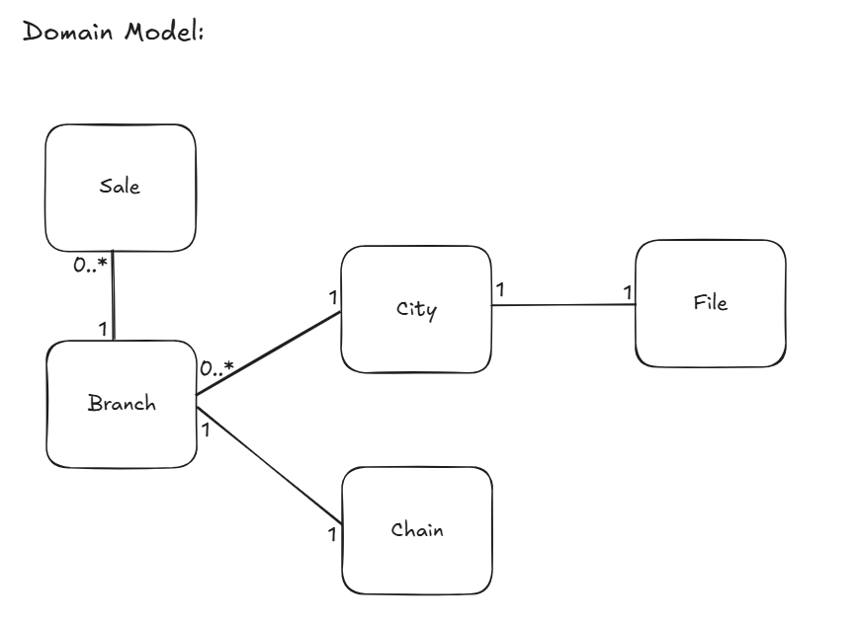

Explanation: Each file describes exactly one city. Each City contains multiple branches,but a branch can only be in one city. Each branch belongs to one chain. A chain can contain multiple branches. There is NO direct relationship between the concept of chain and the concept of city. Each Sale belongs to one and only one branch. A branch can have multiple sales.

For each city there is a file produced listing the hamburger purchases in that city, with each purchase recorded as: the chain’s name, separated by “, ” (comma and space).

burger king, burger king, McDonalds

If a sale includes multiple burgers, there will be multiple entries in the file.

**Input**: A directory of files that describe the sales. One file per city in the format above. The name of the file is the name of the city.

**Output**: The system outputs a single winning chain with the highest total sales (ties are broken arbitrarily).

**Constraints & Assumptions**

1. The system handles up to 1020 cities (i.e., up to 1020 files).
2. Each file can contain up to 1024 distinct hamburger chains.
3. No ", " substring appears inside a chain’s name.
4. A chain's name can have spaces and other alphanumeric characters.
5. A city cannot have 0 sales. If there were no sales that year, the city file does not show in the directory.
6. A branch can have 0 sales for that year.
7. The name of the branch must be exactly the same in all appearances in all files.
8. Files do not change during processing (batch mode).

**Performance requirement.**

The system must complete within one minute.

**Implementation**

**Due to the need for low return times, we decided to implement the system as a multi threaded system.**

This specification describes the multi threaded implementation

A default 5-second timeout is used for detecting stuck thread or file.files (configurable as needed).

**Technical requirement:** This system is designed for parallel (multi-threaded) processing of hamburger sales data across multiple cities. The system’s goal is to merge all data and identify which hamburger chain achieved the highest sales nationwide over a certain time period, and to return in under 1 minute.

**Technical Considerations**

1. **Parallel Execution (Multi-threading):** Maximize CPU utilization by concurrently processing multiple files.
2. **Fault Tolerance:** Implement a monitoring mechanism to detect and recover from worker failures or delays, ensuring that all files are eventually processed.
3. **Result Aggregation:** Efficiently merge partial results from all files into a single data structure to identify the top-selling chain.

**Architecture & High-Level Flow**

1. **Key Data Structures:**
   * **task_queue (Queue of file paths):** A FIFO queue containing the file paths awaiting processing.
   * **task_status (Dictionary):** Tracks each file’s status (pending, in_progress, done) along with a timestamp marking when it entered its current state.
   * **global_results (List of Hash Tables):** Stores the local counts of each hamburger chain from every file processed.
2. **Threads:**
   * **Worker Threads:**
     + Dequeue a file path from task_queue.
     + Mark the file as “in_progress” in task_status, including a timestamp.
     + Process the file’s contents (count how many times each chain appears).
     + Mark the file as “done” in task_status and append the local hash table to global_results.
   * **Monitor Thread:**
     + Periodically scans task_status (e.g., every second).
     + Identifies files that have remained in “in_progress” longer than a specified timeout.
     + Resets those files to “pending” and pushes them back into task_queue.
3. **Result Merging & Final Output:**
   * Once all files are processed, the system merges the hash tables in global_results into one dictionary.
   * It then determines which chain has the highest sales and displays that chain as the winner.

**Workflow**

1. **Initialization:**
   * The main program reads the list of files from a data directory.
   * It populates task_queue with these file paths and initializes task_status (all files start in “pending”).
   * It sets up an empty list global_results to collect the partial counts from each file.
2. **Parallel Execution:**
   * A number of Worker Threads are created (up to 1020, or fewer if there are fewer files).
   * Each worker fetches a file from task_queue, updates its status, processes it, and then appends the result to global_results.
   * Simultaneously, the Monitor Thread scans task_status to detect and reassign files stuck in “in_progress” beyond the timeout threshold.
3. **Completion & Aggregation:**
   * After all files are processed (task_queue is empty and all files are marked “done”), the threads finish execution.
   * The main program merges all local hash tables in global_results into a single dictionary.
   * It identifies the top-selling hamburger chain and prints the result.

**5. System Components**

1. **main.py File:**
   * Holds the global configurations, main functions, and the main entry point.
   * Initializes data structures, spawns threads, and coordinates final output.
2. **data Directory:**
   * Contains the city files (e.g., TelAviv.txt, Jerusalem.txt) with chain names separated by “, ”.
3. **Worker Threads & Monitor Thread:**
   * Implemented using Python’s threading.Thread.
   * Workers handle parallel file processing; the Monitor checks for and resolves timeouts.
4. **Timeout Mechanism:**
   * Prevents files from remaining indefinitely in “in_progress” if a worker hangs or crashes.
   * Moves stuck files back to “pending” status in the queue.

**7. Expected Outcomes**

* The system outputs a single winning chain with the highest total sales (ties are broken arbitrarily).
* Parallel processing reduces overall runtime compared to a single-threaded approach.
* The Monitor Thread automatically handles failures by reassigning files when a worker crashes or times out.

**8. Future Extensions & Optimizations**

* Use more advanced storage formats (e.g., Parquet) for large-scale data.
* Employ distributed processing frameworks (Spark, Dask) for even greater scalability.
* Implement a cancellation mechanism to handle worker threads that exceed the timeout but do not crash.
* Remove completed files from task_status to reduce overhead when the number of files is very large.

This specification provides an overview of the system architecture, the data structures involved, and the processes that ensure reliable, concurrent, and efficient handling of hamburger sales data.

